Oliver Collins-Cope

2102775@rutc.ac.uk

Learning Aim A

Investigate the principles and methodologies of IT project management as used in the industry.

unit 09 it project management

Assignment 1

Contents

Introduction 2

What is a project? 2

Difference between a project and a process 3

What do IT projects include? 3

What is project management? 4

Planning 4

Organisation 5

Controlling 5

Project life cycle 5

Initiating 5

Planning 5

Executing 5

Monitoring and controlling 6

Closing 6

Different project management methodologies 6

Projects IN Controlled Environments (PRINCE2) 6

RAD 6

Waterfall 7

Agile 8

Project Management structures 9

User requirements 9

Protect job roles and responsibilities 9

Quality Assurance 9

Operational test environment 9

Live deployment 9

Comparison of different methodologies and structures 9

Evaluation of different methodologies and structures 9

# Introduction

IT project management is involved in almost every part of IT, as when working through different projects, whether it be developing software, making a game, or even producing an operating system, it is crucial to plan and manage the project constantly in order to ensure constant communication between departments, with everyone knowing what they have to specifically work on. Furthermore, IT project management ensures that the processes of the project are efficient and effective.

# What is a project?

A project can be defined as a sequence of tasks that have to be completed to finish a larger task, usually within a define beginning and end period (deadline). Projects often include a budget to meet these goals and are undertaken by individuals or groups with the tasks broken down to complete sequentially in order to achieve the next goal.

Within projects it is crucial to break down the goal into manageable and doable tasks which can be completed by the members, otherwise the chances of becoming overwhelmed with the work and designing and developing in the incorrect order, which can cause catastrophic consequences later down the line due to your code and design being dependent on each other.

A project can also be displayed through three primary points of focus:

* Time
* Budget
* Scope

Time refers to the time spent on the project, including beginning dates and deadlines to be completed by.  
Budget refers to how many resources have been allocated to the project, whether it be manpower or funding.  
Scope of the project refers to documenting the project boundaries and what the main objectives are.

This diagram can help to understand the relationship between the points of focus.

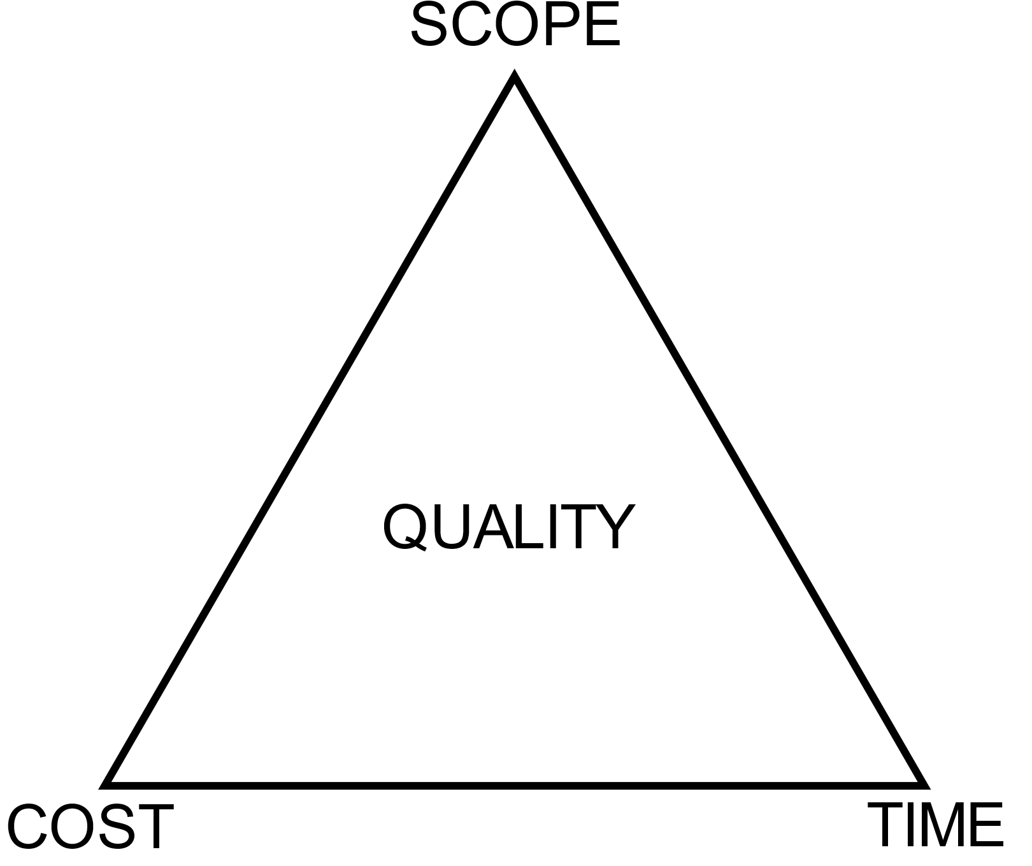

## Difference between a project and a process

It can often be confusing to understand the difference between projects and processes and their relationship with each other, including how they communicate, so it is important to clarify how these vary and what the key differences are.

While a project is usually long term, including a start and end date, processes are established procedures that help with ongoing work. These can be changed constantly and are not strict in what they contain. To help further understand the difference between a project and processes it can be helpful to view them through their relationship.

C:\Users\2102775\Downloads\pjct x prcss.drawio.png

Through this we can understand that a project has many processes, however a process belongs to the instance of that project. This means that a project is a parent process (usually) and the process is born out of the project. While there are some scenarios where a project can also be a process or be born out of a project (making it a process), this is rare and only seen in much larger scale projects made up of multiple smaller ones.

## What do IT projects include?

IT projects in particular include more specific definitions for what is typically involved in the overall project. In no particular order, this commonly includes:

* Software application development
* Installation of IT systems and networks
* Information collection
* Analysis
* Maintenance

#### Software application development

Software application development consists of physically making the software that the company or individual has been contracted to make (in the example of business). This can also be extended to include processes like design, testing, and refinement. Generally, software application development will happen once the requirements and design of the application has been reviewed and approved by the client and project manager, ensuring that everyone is happy with how the software will be developed.

#### Installation of IT systems and networks

Installation of IT systems and networks can refer to both physically and digitally installing IT systems for a company or individual.

Physically installing IT systems and networks is comprised of being on site in the location and manually installing the IT system, whether it be a desktop computer or a server rack for the company, both vital components for businesses to function. This can also include mundane jobs like establishing cable links between the servers and desktops so they are able to access each other.

Digitally installing IT systems consists of installing software for the users to use so they are able work with the required applications for their business or company projects.

#### Information collection

Information collection within IT projects refers to activities where members of the project are able to share data with each other to help advance the project.

An example of a common information collection activity would a meeting, where people establish what they are doing and what support or blockers might be affecting them in their work. Furthermore, meetings will also happen between the client and company in order to remain updated about their project and allow for new input from the client incase situations arise.

#### Analysis

Analysis within an IT project refers to analysing the requirements of the job and what will need to be accomplished in order to achieve success. This can vary from analysing what the program that will be developed is supposed to do and seeing what steps have to be taken to achieve this goal.

#### Maintenance

Maintenance in an IT project means to ensure that the delivered program will continue to function smoothly, providing software updates to the technology and fixing any bugs that occur to destabilise the program.

## What is project management?

Project management can be defined as the process of planning, organizing, and controlling a project and its activities in order to ensure that the project is completed successfully within the previously referenced three primary points of focus within the project. Alongside this, it is also important for project management to mitigate any appropriate risks and resolve any problems or issues that may arise during the project’s lifetime. These three processes mentioned can be further broken down to gain a better understanding of them.

### Planning

Planning within a project can vary vastly in what must be accounted for and achieved within this time period of the project. For example, this can range from planning the tasks that have to be achieved in the project in order for successful completion of the project, to planning how to split up personnel and departments and assigning work. Planning ties in closely to organisation and as such the lines between what is planning and what is organisation can be regularly blurred, so it is necessary to understand that these outlines, the outlines being planning, organisation, and controlling, are intentionally vague and only serve as to help establish the project, and thus can be easily manipulated and merged depending on the situation.

### Organisation

As previously mentioned, organisation and planning can often merge together depending on the situation and the individual’s interpretation on what organisation and planning include. Typically, in organisation within project management is responsible for identifying the roles and responsibilities of each position that facilitates coordination and implementation of different project activities. This means that it is necessary to identify and define all the roles of the different team members in order to effectively organise and execute the project.

### Controlling

Controlling a project refers to how the project is managed while it is ongoing. This includes responsibilities like tracking and managing the core project elements with regards to the three primary points of focus, those being time, cost, and scope, in order to effectively run the project and achieve the product decided on before the deadline and within the budget. Further duties of controlling the project can be adjusting the course of activities and swiftly making changes in order to resolve blockers which might inhibit the progression of the project due to unaccounted, or accounted for, variables which impact it.

## Project life cycle

A project generally follows a life cycle of five main stages, and although that most projects will follow this structure, the order in which these stages and steps are implemented depends on the project methodology that is being applied to the project.

### Initiating

Initiating a project is the first stage in the project life cycle, and this step includes outlining the justification for the project alongside the requirements to achieve a successful outcome.

### Planning

Planning a project is the second stage in the project life cycle and includes the information regarding how the project will work, with regards to how it is going to be carried out, and then monitored and controlled to achieve the end of the project successfully.

### Executing

Executing a project is the third stage in the project life cycle and handles the human resources, i.e. dividing the teams up to develop separate parts of the program, and the other available resources such as programs to help aid development. This is all to help undertake all of the tasks of the project within the constraints time, cost and quality.

### Monitoring and controlling

Monitoring and controlling is the fourth and penultimate stage in the project life cycle and it includes, as the name says, monitoring and controlling the project in line with the initiation and planning documentation in order to achieve the end of the project.

### Closing

Closing the project is the fifth and final stage of the project life cycle and is the formal process of closing and ending the project. During this time, it can be common to review the original goals again and compare it to the final product, learning from the success and mistakes of the project.

# Different project management methodologies

There are a variety of methodologies that a project can utilize in order to effectively complete and execute a project. It is important to understand the different methods of project management available as it allows the project manager to choose the best method available for and effectively execute the project.

## Projects IN Controlled Environments (PRINCE2)

The PRINCE2 methodology is a methodology that primarily focuses on a process-based approach with heavily emphasizes organisation and control from start to finish over the whole project. As the name suggests, PRINCE2 is the sequel to PRINCE and was initially developed over four decades ago. It is primarily used by the British government and the UN currently. It ensures six goals that should be defined, as well as seven principles that every PRINCE2 project should ensure. The six goals include:

* Scope
* Timescale
* Risk
* Quality
* Benefits
* Cost

And the principles of PRINCE2 include:

* Continued business justification where each project should have a clear need, a defined customer, realistic benefits, and a cost assessment.
* Learn from experience where each team member should gain experience in order to help improve future performance.
* Roles and responsibilities should be clearly defined between each member so everyone knows who is responsible for what.
* Manage by stages where the work is broken up into individual phases to be worked through with periodic reviews.
* Manage by exception where in the instance of issues arriving that impact established requirements, rather than the project manager resolving it the issue is escalated and a board will resolve it.
* Focus on quality where the deliverable projects are checked for quality to ensure the product is of high quality.
* Tailored approach where each project has its own needs and adjustments that must be made in order to achieve a successful project.

## RAD

The RAD methodology is a precursor to the Agile development methodology and is generally suited for short-term, large-scale projects, similar to Agile, and is known for having a short turnaround time. This short turnaround time is what makes RAD such an attractive project management methodology for specific fields like IT. It also ensures to remain open-ended meaning that the client is kept involved in the project and it remains easy to make changes in the project.

The different stages of RAD include:

* Requirements planning where the project members, including the client, communicate to determine the goals and expectations of the project along with any current and potential issues that might need to be addressed.
* User design is the stage where the developers work hand in hand with the clients in order to ensure that their needs are met at each stage of the design process and the prototypes that are developed function smoothly and meet the clients needs. In this phase, the bugs and kinks are also resolved through an iterative process much like Agile. This phase also includes various stages internally, such as verification and validation of code, configuration of the program, metrics and measurements, and general project management such as scheduling.
* Rapid construction involves taking the prototypes and beta design systems and from there converts them into a working model. Due to the previous iterative phase most of the bugs and kinks have been resolved and therefore development can be focused on the final working product. This phase of development can be broken down to smaller steps, those being preparation for rapid construction, program and application development, coding, unit integration, and system testing. This stage also includes communication with the client which allows for the client to add input and possible help solve any problems, ensuring they are satisfied with the final project.
* Cutover is the stage where the finished project goes to launch and includes systems like data conversion and final testing. Final changes are made now while bugs can be discovered and resolved.

Some benefits of the RAD methodology include:

* Task oriented structure
* Client is involved
* Easy to make changed
* Regular communication between team and client
* Risk control

Some of the limitations of RAD include:

* Less control on the overall project
* Can be rushed design and app
* Lack of scalability
* Unable to plan for the future

## Waterfall

The Waterfall methodology is based on planning and accounting for every variable in each of stage of the project. This means that it can take months before any development takes place in a project as there will be a large focus on the planning and requirements aspect before it can advance onto the next stages. Waterfall is often suitable for plans that are very clearly outlined from the beginning with a concrete timeline and well-defined deliverables.

The different stages of Waterfall are:

* Requirements where the projects product requirements and end goals are documented for the future development.
* Analysis where the project management develops the system for the project that will be followed.
* Design where the different elements of the project that might need design planning, like program architecture and UI elements.
* Implementation of the three previous steps and ongoing development of the project and software, etc.
* Testing where the project focuses on searching for bugs within the code and fixes any uncovered issues.
* Operation/Deployment of the final project and the delivery of the software/program.
* Maintenance where the final product is updated and any issues that arise are dealt with.

Some of the benefits of Waterfall methodology include:

* Easily copied in the future for successful projects
* Simple to understand
* Timeline of events, all planned out
* Outputs of project visible at each stage

Some of the downsides and limitations of the Waterfall methodology includes:

* Difficult to make any changes to plan
* Expensive to make changes in plan
* Inflexible
* Not suited for constantly changing programs/projects
* Difficult to know everything required during the requirements and planning phases

## Agile

The Agile methodology is based on working through ‘sprints’, which usually last 1-2 weeks and consist of daily meetings where team members mention what stage in their work that they are in and what is blocking them from continuing their work. In this, work is prioritized based on what is important and critical to what can be dealt with later, which leads to a backlog of work and therefore a constant workflow. It is more suited for longer term projects where changes can be made regularly. Feedback is critical within Agile as it allows for the product to move forward in a positive direction that will ensure that the customer is satisfied with the final result.

The different stages of Agile include:

* Concept or iteration phase 1 where the scope of the project is decided and different projects and processes are prioritised.
* Inception or iteration phase 0 where the projects team is slowly built and the initial planning and modelling of the project takes place. The prototypes and MVP can be decided during this phase as well.
* Iteration or construction where the project team work to turn all of the design and feedback from the customer through ‘sprints’ of work. This is one of the most important phases of Agile development as it allows developers to create software swiftly and make improvements that will be able to satisfy the customer. Each sprint is reviewed by a scrum master who manages the sprints and is then adapted for the average workload possible during the sprint.
* Transition and release phase where the product is released on a small scale alongside software testing to smooth out any kinks in the software and ensure a wild scale release is as bug free as possible.
* Maintenance or production phase where the product is released to the customer or wider market while maintenance and bug fixes are available and support from the developers is available to understand how the program works.
* Retirement phase where the program is either removed from development due to being replaced or has become obsolete, either way the project and product is no longer being worked on.

Some of the benefits of Agile methodology include:

* Flexibility
* Clear outputs from each iteration
* Appropriate use of resources
* Satisfied customers do to constant feedback
* Adaptability
* Predictability due to working in short bursts
* Less risks as it is cheaper to catch mistakes and errors earlier on
* Better communication i.e daily meetings

Some of the limitations of the Agile methodology include:

* Requires fast communication and effective teamwork, work often depends on others progressing at a similar rate
* Limited documentation due to fast work pace
* No finite end
* Difficulty to tell when project will be finished

# Project Management structures

## User requirements

## Protect job roles and responsibilities

## Quality Assurance

## Operational test environment

## Live deployment

# Comparison of different methodologies and structures

# Evaluation of different methodologies and structures

# Bibliography

Chart, L. (2022, October 6). *Lucid Chart*. Retrieved from Lucid Chart: https://www.lucidchart.com/blog/rapid-application-development-methodology

Chart, L. (2022, October 6). *Waterfall project management methodology*. Retrieved from Lucid Chart: https://www.lucidchart.com/blog/waterfall-project-management-methodology

Wrike. (2022, October 6). *What is Agile*. Retrieved from Wrike: https://www.wrike.com/project-management-guide/faq/what-is-agile-methodology-in-project-management/